**Boston University**

**Electrical & Computer Engineering**

**EC463 Senior Design Project**

First Semester Report

Running Safety Plus

Submitted to

Professor Alan Pisano

Boston University

(617) 353 6264

apisano@bu.edu

by

Team 22

Running Safety

Team Members

Thomas Cimino tpcimino@bu.edu

Zexing Gao zexing@bu.edu

Cong Han hancong@bu.edu

Payton Hauck phauck@bu.edu

Yajing Lai cassielo@bu.edu

Submitted: 12/11/18

#### Table of Contents

Executive Summary 2

1.0 Introduction 3

2.0 Concept Development 5

3.0 System Description 7

4.0 First Semester Progress 9

5.0 Technical Plan 11

6.0 Budget Estimate 13

7.0 Attachments 14

7.1 Appendix 1 – Engineering Requirements 14

7.2 Appendix 2 – Gantt Chart 15

7.3 Appendix 3 – Other Appendices 16

# Executive Summary

Running Safety Plus

22 – Running Safety

Running Safety Plus is a safety device used by runners or joggers of all ages that will be useful for emergency situations of any type. Comfortably concealed and durable enough to fulfill all of its functions, our device will track GPS coordinates, heart rate, the running force, and contact an emergency contact if needed. Our device consists of both a shoe insert and chest strap to help avoid false positives and provide a more accurate detection of emergencies. Using a GPS, sim card, and bluetooth functionalities, the device is programmed through a web application which is where preferences are set and data is stored.

# Introduction

**1.1 The Problem**

In the United States over 64 million people responded that they jog or run regularly in their free time as a source of exercise. Specifically in the state of Massachusetts, running is seen as the most common form of exercise for people of all ages. This common form of exercise is usually completed alone and, depending on the environment surrounding that runner, could be dangerous. As our customer explained, there has been a rise is the amount of reported abduction or sexual assault attempts to young women while jogging alone. Health emergencies are other common dangerous situations that can occur to runners if they are out on their own, leaving them stranded with no one around to help them in some cases. Unfortunately, there is an absence of devices in today’s society that can help with these types of situations and the few that exist lack qualities that make them truly helpful to all runners today.

**1.2 Our Solution**

Our team plans on solving this with the help of our customer by designing a functional device that can help runners of all ages be more safe during their exercising routines. Our design will consist of two parts including a shoe insert and a wearable chest strap. Notice how both of these parts will be concealed and therefore not easily seen by the public eye, which can be very important in certain emergency situations. Our device reads heart rate, GPS location, the force exerted by the runner, and will take all of these readings and communicate with an outside emergency contact.

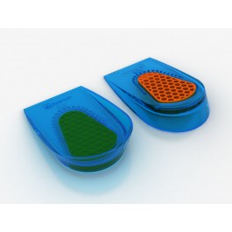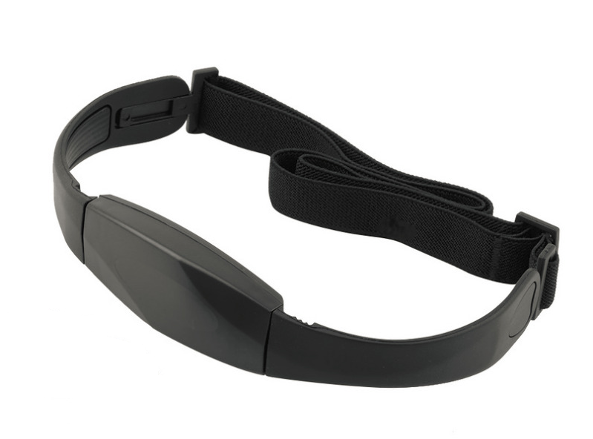

Figure 1. Example design

of the chest strap that will be

worn by the runner.

Figure 2. Design idea of how we will cover and insert our shoe device.

**1.3 Team Approach**

In order to design a strong and efficient device, our team approached our design by focusing on three main measurements to determine if an emergency is taking place. First, measuring one’s heart rate for abnormal spikes is an easy way to determine if the runner is undergoing some type of stress. Heart rate spikes can be caused by a rush of adrenaline which usually occurs when one is in a dangerous or emergency situation. Heart rate measurements also help to signal when a user is undergoing a health emergency, which is another type of emergency we are monitoring. Our team thought approaching this problem with this as our focus would help solve the stated problem in a very efficient and accurate way.

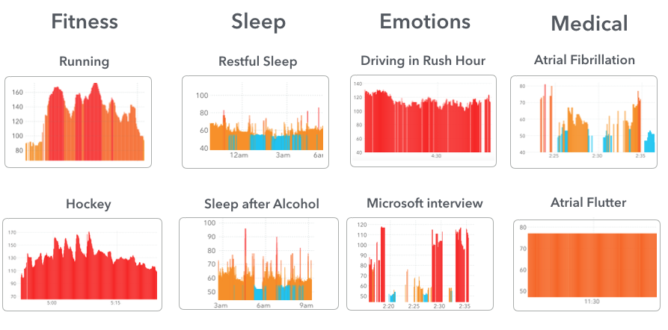

Figure 3. Diagram of comparing heart rates during certain situations.

Figure 1.1 Comparison of Heart Rates in Situations

Our other approach to detecting an emergency is through the use of a force sensor that will be part of the shoe insert. This will signal whether or not the user is actually running. Obviously, if the user is not running there will be no force reading and if they do not cancel the alert then there's some type of situation that needs help. This approach seemed like a simple, yet efficient way to measure whether the runner was actually in motion and okay or if a possible dangerous situation was occuring.

Finally our last approach involved tracking the user’s GPS location and this is helpful in many ways in that if there was an emergency, we have the location of the runner. GPS location is very common and can easily be integrated into many devices these days and our group took advantage of this. This is a main part of our group’s design and is crucial to the use of our device. We believe that all three of our approaches to this device help create a design that is efficient and will be useful to all runners. By being simple and easy to understand by many, runners of all ages will have access to this device, ensuring them that they will be safe during their runs.

# Concept Development

**2.1 Customer needs:**

Our customer wants a device that can automatically detect danger, and send a help signal out to save the user’s life. This is because people that may be jogging alone can often be in danger, especially young women. This device will be a concealed device which the runner wears in a concealed location, suggested inside a shoe, which senses when something is wrong and will automatically send a message to the emergency contact(s). This system will be a self-contained device, not relying on the user’s cell phone or on an easily thwarted action such as yelling or a button push. If the user is not in trouble, they can press the button to cancel the emergency signal transmission.

Our customer explained that portability is an important part of the device since the runner will be in motion while using it. With safety being our main focus, we will design our device to be available to all ages, therefore being rather easy to use. Our other main focuses for this device include being comfortable, concealed, and durable enough to fulfill all functions our customer finds necessary. We decided to use both a chest strap as a wearable part and a shoe insert chip, not only for comfort but also as a security concern. These two portions will be connected with each other and make the alert system more accurate and stable. This device will eventually be seen as a necessity to the safety of runners as well as a want for many across the country.

**2.2 Engineering requirements**

The first requirement is to make sure the device is undetectable. We have decided to make it a two-part device consisting of a chest strap and shoe insert, which allows for both concealment and comfortability. The chest strap should have a range from 17 in to 31 in in order to works for different ages.

The customer asked for the device to track the runner’s location, so we decided to use a GPS module and SIM card. The SIM card will help connect the runner with our web page which will display the runner’s location. The GPS module is also another huge part of tracking our runner, in that their location will be gathered using this module to be sent to the emergency contact provided. We also decided to implement a more beneficial implementation in that we take the coordinates gathered and use that to find a link that will provide the emergency contact with a map interface so that they can visually see and understand the runner’s location more clearly.

The duration of the usage is also mentioned by our customer. In order to achieve portability, the device must be of certain size and have a portable power supply. In terms of power, it was decided to use a rechargeable battery, which would allow for at least a 6-hour run time. This approach allows for the device to be moved around and recharged when needed. The battery life of our system can be seen as the most important requirement of our project, due to the fact that it must last for the runner’s entire running session length. Furthermore, it was decided that the dimensions for portability are a maximum of ​2 in x 2 in and weigh no more than 0.25 lbs. These dimensions can be easily compared to today’s apple watch which is a device many use during everyday use and even during exercise.

The key aspect that concerns the customer is the accuracy of the detection and the automatic actions of the device. Our customer wants the device to automatically detect the emergency situation and take action immediately and send the GPS coordinates to an emergency contact automatically. We use a pulse monitor and a force sensor to ensure the accuracy of the detection, and use Twilio integrated into our own web page to send out the SMS message after receiving the emergency signal from the device. Moreover, our device will be as small as possible to hide inside a runner’s shoe and under their shirt, which will help the device be hidden from the public eye which is very important in some emergency situations.

**2.3 Conceptual approach**

In the beginning, we wanted the device to send messages directly to 911 when it senses danger. After doing the research on Massachusetts Law, we noticed that it is not possible for us to send messages directly to 911, so instead we chose to send the emergency messages to a programmed emergency contact that will be stored in the web database. With the help of Professor Osama, we found an API that will help us forward the emergency message to the stored emergency contact given by the user. Twilio is the API that we will integrate into the backend of our script that will help send these messages to our emergency contact.

Originally we were only going to send the GPS coordinates we gathered to the emergency contact, but we realized that it may be hard to understand and also not enough information depending on the situation that is taking place. We then decided that we will be sending along a link that will connect the user to Google Maps showing the actual location of the runner at the moment of the emergency. We also will be including the contact information for the nearby police station along with this link incase the emergency contact feels they need to contact officials.

Initially we planned on using a bracelet as the wearable device that includes a pulse sensor, but after testing and further consideration, we decided that a chest strap instead of the bracelet would be better for many reasons. First of all, a chest strap allows the pulse sensor to get closer to the human body, more specifically the heart, and measure the pulse value much more precisely. Also, a chest strap is a safer choice for the runner, in that it would be rather difficult for it to get ripped off by possible attackers or even other objects that may come in contact with their arm. Finally, trying to fit as many devices as we have into a small wrist bracelet would be rather difficult, but by expanding our dimensions to the size of a chest strap would really help. Therefore, we can fit more into the chest strap, while also having the device hidden from the public eye.

When first considering ideas, we wanted to preset the route that runners will take into our web application and check whether the runner is out of range while they are running. However, after a lot of research, we found out that it would be very hard to implement the route preset function in the web app. We also did not want to restrict the runner to a certain route incase they decide to change their mind during the running session. Moreover, if we keep track of the runner’s current location the entire time, it will cost a lot of battery power. Instead, we will only be storing instances of the GPS location to use less battery power, but still have an updated reference to the user’s location. In the end, we will not be implementing the preset route option into our system.

Our approach overall for this project to primarily make sure our user is safe and the system works for all types of emergency situations. Our device is easy to understand and can be used by runners of all ages, making our device one of the best options!

# System Description

**3.1 System Diagram**

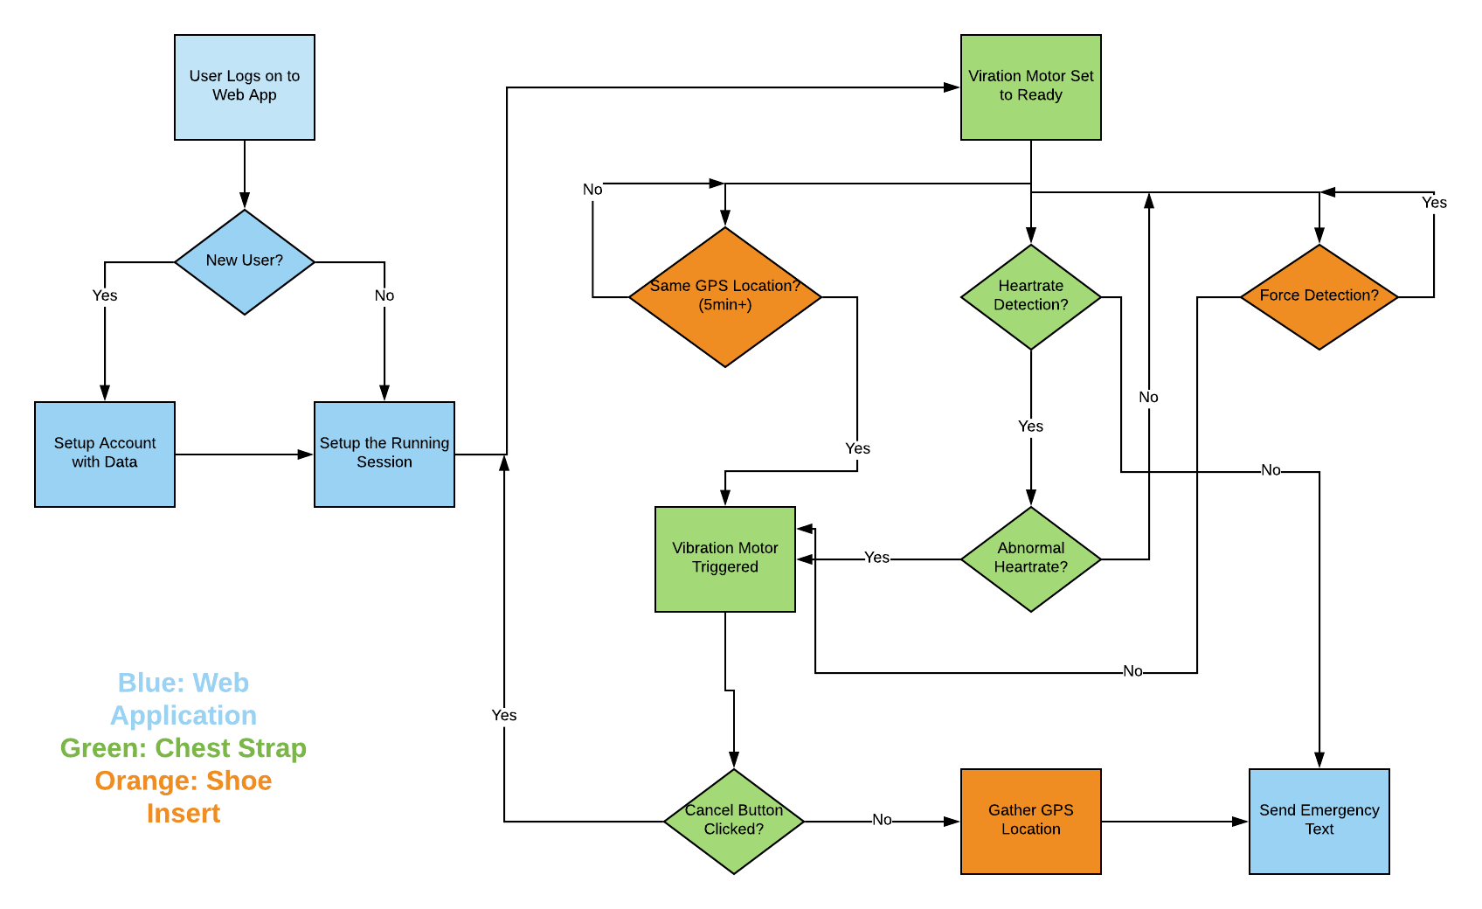

Figure 4. Block diagram of the Running Safety System.

Our system block diagram outlines our entire system and how it functions within each individual system. Starting with the web app the system is pretty basic to understand. The runner will log into the designed web application and either create a new account or continue on with their set account. The account will store the user’s personal data such as basic information about the user, an emergency contact, and it will also continue to store data that our device measures throughout each use. When the user logs on, they will program a running session so that the device knows it will be used, and the user can even give an approximate for how long or far they are looking to run if they would like to.

After they set up the running session the user will now be ready to put on their devices and begin their run. As soon as the devices receive the data that was set in the web application, the vibration motor in the chest strap will be set and ready to go. As soon as a heart rate is detected and there is a force being measured the system is in action. The systems will continue to monitor data and go through an ongoing loop of measuring and checking the heart rate, force detection and GPS location. Normal measurements of data consist of a normal heart rate, a consistent force detection, and a changed GPS location after five minutes. Abnormal measurements that may cause an alert is if there is not a consistent force detection, a GPS location that has been the same for five or more minutes, and a heart rate that is abnormal. The only reading that will go straight to an emergency text and not to an alert system first is if there is absolutely no heart rate coming from the device. This would mean that the runner does not have a heart rate or that the chest strap was ripped off.

Following the reading of an abnormal measurement, the vibration motor would be triggered and turned on to alert the user. The user then has the option to cancel the alert through a button on the chest strap if the reading was indeed a false reading. If the user does not cancel the alert within 10 seconds, then the most recent GPS location will be gathered and the emergency contact programmed to that user would be contacted immediately. Currently our team is only sending a Google Maps link with the GPS coordinates to the emergency contact, but our team hopes to send out a more effective and useful text or call. We also plan to send along the contact information of the police station that is nearby to the runner.

**3.2 Software Web Application**

In our Appendix, photos of our current software interface can be found. So far our team has a simple web application that includes a user login or sign up that is then redirected to a home page that includes a map and current location. At the moment the current location of the web user is shown, but eventually the location of the runner can be shown once tracked through our system. Although the system is very basic in development at the moment, there are only a few operations that need to be performed by the web application.

Storage, user authentication, communication with emergency contact, and communication with the hardware are the main integrations that are involved with our web application. Also, our users need to be able to easily change any of their data and even access past data that is stored with every use of our device. As seen through the figures found in the appendix, many of the simple integrations have been completed, but our team now needs to clean up the interface and make it easy to use and visually pleasing for the user.

**3.3 Hardware Integration**

In our appendix, the schematic for our device can be found and that outlines the different parts that are included. Again, there will be a shoe insert along with a chest strap that will both contain all necessary hardware components needed for our project. The main parts consist of the GPS module, SIM module, bluetooth modules, two Arduinos, a force sensor, a heart rate monitor, and a vibration motor. Each device provides a specific function that contributes to the overall system working. Within the shoe insert we currently include the battery, force sensor, GPS module, and the SIM module. For the chest strap we include the heart rate monitor, vibration motor, and the bluetooth and Arduino. The team is currently deciding if including more in the chest strap would be beneficial to the size and comfort of our overall device.

# First Semester Progress

**Hardware**

During this semester, our team has seen considerable progress from our initial design stages. We have validated that our GPS, GSM, Bluetooth, and pulse monitor modules all work as expected, and that we can combine them all into one total system that works as we intended. Currently, we have the “shoe” side of our design working as it should as well as our “chest strap” side of the design. On demo day, we will be able to demonstrate that our total hardware system (shoe and chest strap) works as one unified system. We’ve been able to implement the shoe device so that it reads the pressure from a user’s stride, and if there isn’t a stride for 10 consecutive seconds, a warning signal is sent to the chest strap device. This then sets off a warning vibration motor that the user will be able to feel, but will not be detectable to a third party. The user then has another 10 seconds to cancel the emergency signal by hitting a button on the chest strap device, and this will return the total system back to normal. If the user does not hit the button, the chest device sends a signal back to the shoe device, confirming to the device to take the current GPS location, parse out the latitude and longitude, and send those in a user-friendly format to an emergency contact that the user inputs on the web application. The repeated force under the user’s heel is the primary way we have programmed our system to detect if there may be some sort of distress situation, with the backup being a pulse monitor. Since every person will have different ranges of heart rates for different activities, we programmed the device to detect abrupt spikes in heart rate, not discrete levels, since these abrupt spikes from adrenaline will be much higher than an increase in heart rate from exercise. We have been able to demonstrate all of these capabilities of our hardware system this semester, and look forward to implementing them into our final design next semester.

We have also begun putting together a list of different courses of action for next semester with the implementation of the hardware in mind to present to our customer. We have some concerns about how all of the modules of the shoe device will actually fit into an actual running sneaker and still be comfortable, so we have outlined three possible solutions to the problem, which we will talk through with our customer before any permanent implementation is done in the coming semester. Course of Action (COA) 1 is to leave the device as is. COA 2 is to migrate some of the modules of the shoe to the chest strap device. COA 3 is to do away with the shoe device altogether and just have a chest strap. We’ve laid out the pros and cons for each option and we think COA 2 is the best way forward, and will be contacting our customer shortly to get his thoughts and approval as well.

**Software**

We finished half of the web application in this semester. Software development is a very important component in our project. Our user can monitor their location and physical status by using hardware, however, they can only access these information through software. Meanwhile, the software application is also responsible for sending emergency message to the contacts, which is the core requirement for our project. To be specific, we did the following things in this semester.

1. Users have to register into the system at the first time they get the hardware device. A good user interface is important. We built a login page by using JavaScript, HTML, and CSS style sheet. The login page includes backboard image, login/register text fields. (Front-end only)

2. Web users should have the ability to see the location of hardware device user. Real time location is critical keeping runners safe. We built a home page with the Map View. User can see their current location by using this map. We made it by using Google Map API through JavaScript. The code is adopted from google documentary.

3. We built a page jump function. User can login to the system and see the Map View page. We did it by using JavaScript.

4. One of the core requirements for this project is notify emergency contacts when runners are involved in dangers. Twilio can send runners location to emergency contacts so that emergency contacts can save these runners right in time. We implemented SMS method in this web application. I used Twilio server to help me achieve it. By calling Twilio, I can edit and send text message to the user/users I wish to notify. This function is implemented by using node.js.

5. We also deployed our web app to the AWS. We created a virtual machine with Linux and put the js file and html file in the virtual machine and ran it. Since IP address will change every time, we applied an elastic IP address which will not change. Then we associated the elastic IP address with the virtual machine address then link our domain name “[www.seniordesignrunningsafety.com](http://www.seniordesignrunningsafety.com)” to the elastic IP address. Also we set type to the custom TCP rule with the port range 3000-8080 and every user can use the web app through the link.

In the next semester, we have to integrate all existed software component into one application. In addition, we have to establish the communication between hardware device and software application. After the entire project is finished, we are also responsible for future testing, maintaining and debugging based on future requirements from the client. In order to do so, the structure and framework of the web application should be flexible.

# Technical Plan

**Hardware Technical Plan**

Task 1. Pulse sensor

Lead: Cong

Assist: Tom

*Pulse sensor is to detect the heart rate and it will be put in the chest band since it will be closer to the heart and harder to be detected by assailants. We need to determine which patterns of heart rate should be considered as dangerous so that it can trigger the alarm automatically.*

Task 2. PCB design and Final Implementation

Lead: Tom

Assist: Cong

*The nature of this project dictates that we must minimize the size of our hardware components as much as possible. If the product is not comfortable for the user to wear then that defeats the point of the project in the first place. The main area of minimization will be in designing custom PCBs for the shoe and chest devices and implementing them with the hardware module integration.*

Task 3. Final Testing

Lead: All

*Final testing will consist of putting our device through different test cases in its final form. These will consist of normal use, false alarms, and distress situations. We will make sure that the device works as it should and that the web application relays the information to the emergency contact of the user’s choice.*

**Software Technical Plan**

Task 1. Login function

Lead: Payton.

Assist: Zexing

*Firebase login system should be used in the function. In order to do that, firebase API should be connected. Username characters should be constrained to 6-16 characters. Password characters should be constrained to 6-20 characters including capital character, lower case character, and number character.*

Task 2. Converting coding language

Lead: Cong

Assist: Yajing

*So far, our web application is written in javascript. Since Twilio can be only used in node.js, so we need to convert the current functions and interface to the node.js. We have to finalize the project application in node.js and HTML.*

Task 3. System Integration

Lead: Zexing

Assist: Cong

*Currently we have all our individual functions tested. In order to finalize the application, we have to integrate those functions together. The structure and architecture should follow the requirement of node express. One HTML file is needed in public folder; one app.js file is needed in public folder. two controllers are needed in the controller folder, etc.*

Task 4. Establishment of communication between hardware and software

Lead: Zexing

Assist: Tom

*Currently the communication gap between hardware and software is a sincere issue. Both hardware and software are working individually. We are going to set up the SMS communication by using Twilio API. Hardware device will send SMS message to Twilio account, reporting real time geographic location to the Twilio. And Twilio will distribute this message to all emergency contacts.*

Task 5. Testing & debugging

Lead: Payton

Assist: Zexing, Cong

*After the entire project is finished, we have to test and debug the web application. All functions are supposed to be tested in this process.*

# Budget Estimate

|  |  |  |  |
| --- | --- | --- | --- |
| **Item** | **Quantity** | **Description** | **Cost** |
| 1 |  | Pulse Sensor | $25 |
| 2 |  | Vibration Motor (x2) | $20 |
| 3 |  | Tactile Button switch (6mm) | $2.50 |
| 4 |  | Round Force-Sensitive Resistor (FSR) | $14 |
| 5 |  | Arduino | $22 |
| 6 |  | Breadboard | $6 |
| 7 |  | Adafruit Fona 808 | $50 |
| 8 |  | HC-05 Bluetooth Module (x2) | $15 |
| 9 |  | GPS Antenna | $4 |
| 10 |  | GSM Antenna | $3 |
| 11 |  | Venus GPS Module (x2) | $110 |
| 12 |  | SMA Antenna | $10 |
| 13 |  | Arduino Uno | $18 |
| 14 |  | Jumper Wires | $7 |
| 15 |  | Elegoo Uno | $11 |
| 16 |  | RF Cable Extension | $5.50 |
| 17 |  | SIM Card | $9 |
| 18 |  | Adafruit Fona 800 | $40 |
| 19 |  | SMA to uFL Adapter | $4 |
| 20 |  | Lipo Battery (x2) | $18 |
| 21 |  | SIM Card monthly bill (x6) | $60 |
| 22 |  | Projected PCB R+D Cost | $15 |
| 23 |  | AWS Fees | $3 |
| 24 |  | Domain name | $12 |
|  |  | Total | $504 |

Our projected total budget comes to about $504. There are no unusual or dominating budget items, save for the GPS modules, which makes sense as they are the most important part of our project. Most of our budget has gone to components and our spending has been very front-loaded in regards to this school year. We do not anticipate much spending in the coming semester besides PCB R+D. We do not have any donated items.

# Attachments

# Appendix 1 – Engineering Requirements

Team # 22 Team Name: Running Safety

Project Name: Running Safety Plus

|  |  |
| --- | --- |
| **Requirement** | **Value, range, tolerance, units** |
| Weight | Weight less than 0.25lb |
| Power ( In-shoe device) | 3.3v |
| Power (For device in chest strap) | 3.7v |
| Chest strap length | Range from 17 in to 36 in |
| Case dimension | 2 in x 2 in |
| Sensors | One force sensor measuring pressure (N) |
| Database | All emergency contacts information is stored in Database |
| Web map | Google map for location tracking is displayed in our main web page. (Can see it after login) |

# Appendix 2 – Gantt Chart

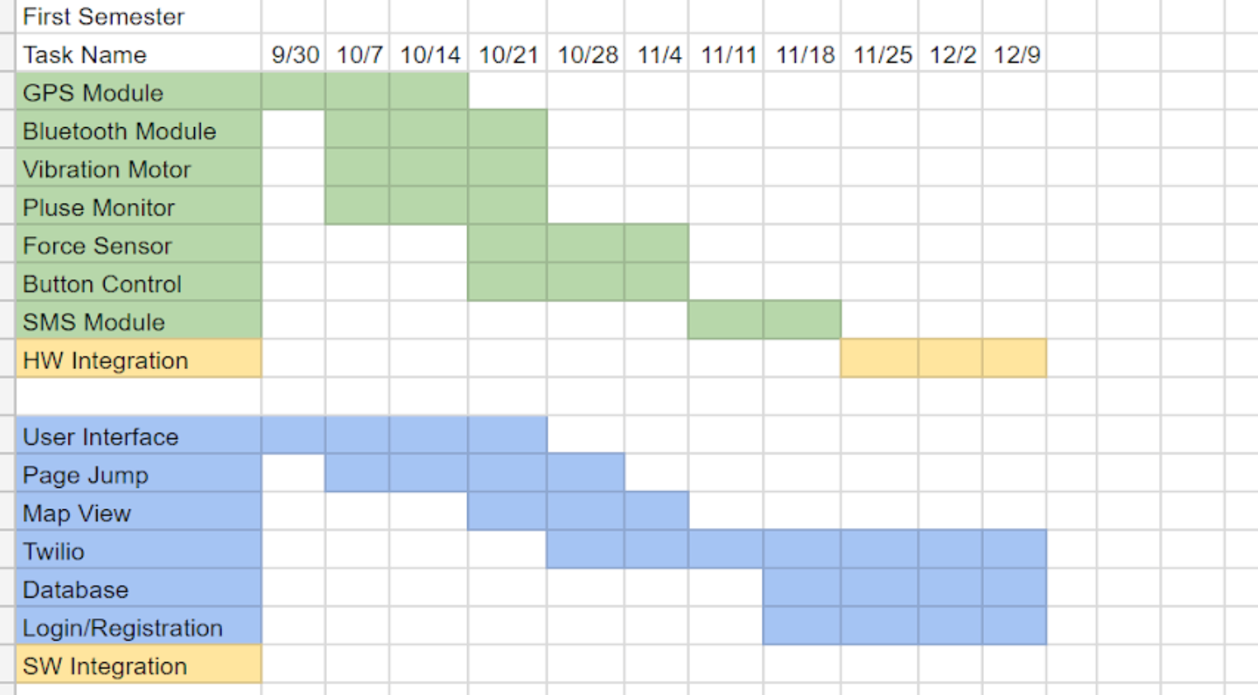

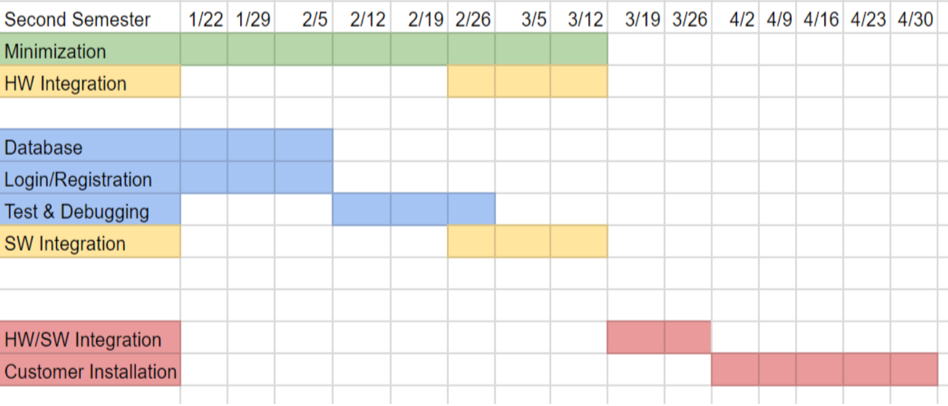

# Appendix 3 – Other Appendices

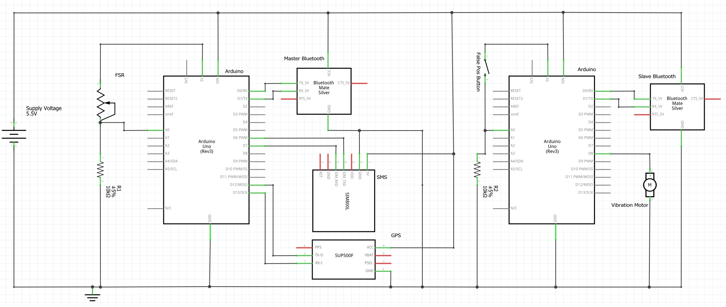

Simplified Device Schematic



Login Page



Home Page